**DAILY ONLINE ACTIVITIES SUMMARY**

|  |  |  |  |  |  |  |  |  |
| --- | --- | --- | --- | --- | --- | --- | --- | --- |
| **Date:** | **10/07/2020** | | | | | **Name:** | **Katira Krishna J** | |
| **Sem & Sec** | **8th A** | | | | | **USN:** | **4AL16CS045** | |
| **Online Test Summary** | | | | | | | | |
| **Subject** | | **-** | | | | | | |
| **Max. Marks** | | **-** | | **Score** | | | **-** | |
| **Certification Course Summary** | | | | | | | | |
| **Course** | **Data Science Methodology** | | | | | | | |
| **Certificate Provider** | | | **Cognitiveclass.ai** | | **Duration** | | | **5 hours** |
| **Coding Challenges** | | | | | | | | |
| **Problem Statement: Python program to implement stack** | | | | | | | | |
| **Status: Completed** | | | | | | | | |
| **Uploaded the report in Github** | | | | | **Yes** | | | |
| **If yes Repository name** | | | | | **Krishna_Katira** | | | |
| **Uploaded the report in slack** | | | | | **Yes** | | | |

Online Test Details:

No test conducted

Certification Course Details:

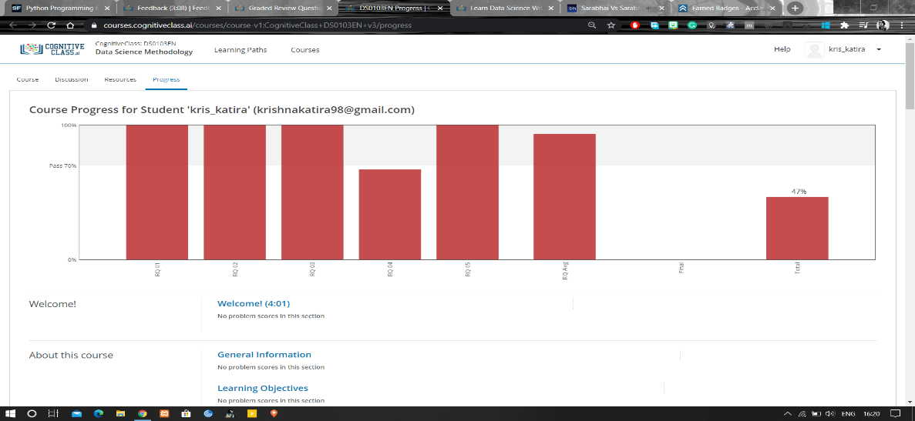

Coding Challenges Details:

**Program:**

class Stack:

def __init__(self):

self.items = []

def is_empty(self):

return self.items == []

def push(self, data):

self.items.append(data)

def pop(self):

return self.items.pop()

s = Stack()

while True:

print('push <value>')

print('pop')

print('quit')

do = input('What would you like to do? ').split()

operation = do[0].strip().lower()

if operation == 'push':

s.push(int(do[1]))

elif operation == 'pop':

if s.is_empty():

print('Stack is empty.')

else:

print('Popped value: ', s.pop())

elif operation == 'quit':

break